
Loyalty Tri-V Umph
Cooperation May 2008
Friendship

President-J. Clingerman-248-788-1378 Sec.-D. Angelosanto-734-422-3501
V. President-M.Trachsel-586-484-0836 Treas.-J. Steinhauer-734-459-4471

President’s Message

Spring has officially started: No more monthly meetings until September, the snow birds are starting to return to Michigan, and the league golf has started. I found out I have bursitis in my right elbow, but it didn't seem to bother me when I was playing golf. Or was it that I just chose to ignore it.

At our April meeting we voted on whether or not to accept Steve Trachsel as a new member and listened to our newest prospective, Dave Burke, describe why he wants to be a member of Tri-V. It is great to have new young men who are interested in joining Tri-V.

In May, we have the open house where members can invite potential members to get a taste of life as a Tri-V member. Let's hope the rain misses us this year.

Have a great spring.

John

Tri-V Wives Club Spring Dinner

All women of TRI-V (significant others, prospective members wives/significant others, etc.) are invited to join us on Wednesday, May 21, 2008 for the TRI-V Wives spring dinner. We will meet at 6:00 p.m. at Brass Pointe Food & Spirits, 24234 Orchard Lake Road, Farmington Hills--10 Mile and Orchard Lake Road. We can order off the menu and separate checks will be available with an 18% gratuity included. Menu consists of soups, salads, sandwiches, dinner entrees, and Mexican specialties. Please RSVP to Jan Cashman 248-669-9209 if you plan to attend no later than May 14, 2008. Reservations are under TRI-V Wives and/or Jan Cashman.

Book Club

On May 5 book club will meet at Judy Lardin's to discuss "Like Dandelion Dust" by Karen Kingsbury. Book Club will meet at Sherry Kuhr's home on Monday, June 9. We are reading "The Book Thief" by Markus Zusak. On Monday, July 7 we will meet at Jacqui Schaefer's. We are reading "A Long Way Gone" Memoirs of a Boy Soldier by Ishmael Beah. All members of TRI-V and friends are welcome to join us to discuss these books. If you've read a book that you think would be a good book for discussion, please let one of the regular members know. The regular members of book club are Victoria Angelosanto, Karlyn Gies, Sherry Kuhr, Ellie Connolly, Jacqui Schaefer, Peg Hoffman, Judy Lardin, Irene Bliudzius, and Renee DeOrtenzio. Others who have attended are Dolores McMillan, Donna Clingerman, and Glenda (Ellie's neighbor).

May Open House
The Men's Open House will be held Saturday, May 10 at Gateway Golf Course, Romulus. The course is located 1/2 mile west of Merriman off VanBorn Road. If you are interested in playing and/or bringing a guest please contact Nick at (734) 522-5366 or victoriadominic@yahoo.com. I have not heard from any members that weren't at the March meeting. Please let me know your intentions.

JUNE INITIATION/SOCIAL

The Initiation of Steve Trachsel into the TRI-V Club will take place on Friday, June 6th, at Speakeasy, Beech Daly and Joy Rds. in Westland. This is the same location as our monthly meeting. Cocktails will be served starting at 6:00pm with dinner at 7:00pm. Your choice of meal will be prime rib of beef or fish. If you have not already let the committee know your choice for dinner, please contact Romas Bliudzius, 734-261-1896, for your selection. The Initiation of Steve will take place following dinner. We will also be playing golf in the afternoon with the first tee time set for noon at Gateway Golf Course. The course is located on Van Born Road, east of Merriman Rd., west of Wayne Rd., in Romulus. Venoy Rd. dead ends at the golf course. We will have the senior rated for all. If you intend to play please let John Lardin, 734-261-1391, know so we can have ample tee times.

Meet Steve Trachsel
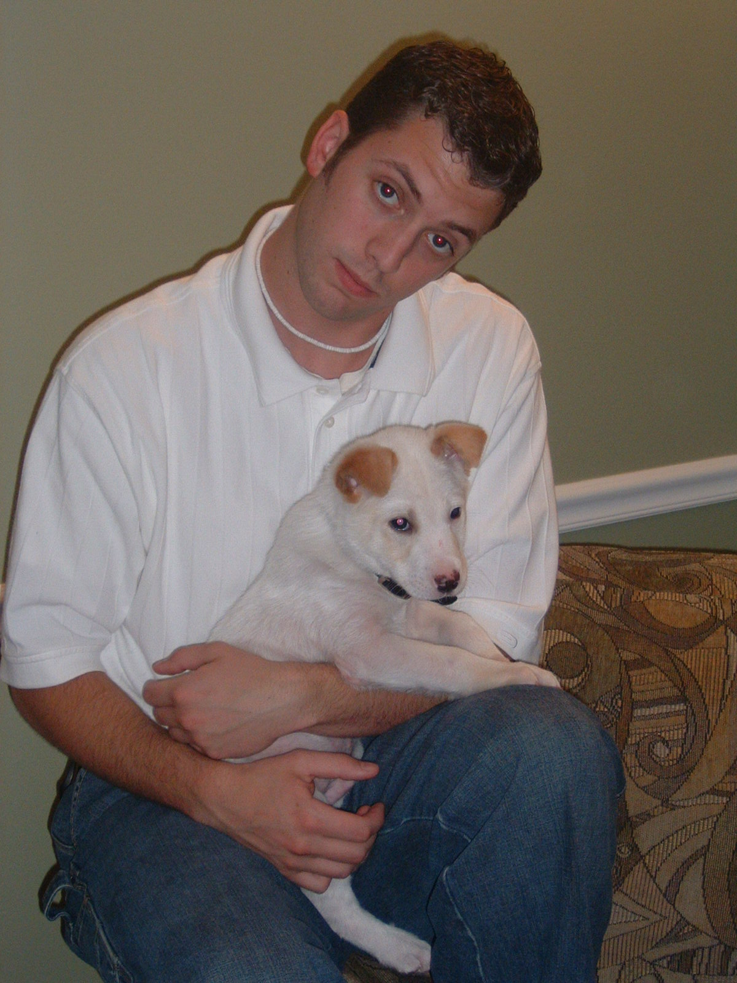
During the April meeting Steve Trachsel was voted into the club to become its newest and youngest member. Steve is the youngest son of longtime members Brian & Jane Trachsel and grandson of Bill & Onallee Trachsel. Steve graduated from Central Michigan University with a double degree in Tech Ed and History. He is currently employed at Frost Middle School in Livonia teaching history. Steve enjoys playing golf, soccer, volleyball and basketball. Steve is also an avid Detroit Tigers Fan. Please make him feel welcome.

Final Golf Outing

Saturday, August 16th through Monday, August 18th
Kendallville, Bestwestern

The Committee has arranged a great weekend for final golf. We will start on Saturday, August 16th at the same course as last year - Glendarin. This is a very nice course, free driving range to warm up (assuming your breakfast is served in a timely fashion so everyone shows up on time, hint, hint). Dinner (2-3 entree buffet) following at Carusos (Glendarin). Sunday golf will be at Bridgewater with dinner following - Prime rib or an alternate. Monday’s golf is at Cobblestone. There will be the breakfast bar available at the Bestwestern and lunches are on your own. The Committee will have snack stuff for the Bixler Room (hospitality suite). We will also provide water bottles for golf on Sunday and Monday. The Tee times are as follows -

Day 1: Sat, Aug. 16 Glendarin Hills 12:30pm (18 holes). Appetizers, dinner following at Carusos (Glendarin restaurant)
Day 2: Sun, Aug 17 Bridgewater East 11:10am (18 holes). Appetizers, dinner following at Bridgewater
Day 3: Mon, Aug 18 Cobblestone 9am (18 holes)

Total cost per person: $343.59 includes 2 nights lodging, tee times listed above, cart fees, taxes, Bixler Room, breakfast bar, meals (2 dinners), and prize money.

Payment info - $100.00 is due no later than July 1st. Please give your deposit to Dick Barnes. Billing for the room, golf, cart, taxes will be billed to you through Bestwestern when you check out on Sunday morning for the amount of $243.59.

It is extremely important to be on time Saturday. It only takes one missing person from the first few foursomes to completely wipe out the format. We are asking everyone to be there no later than 11:30am. They have a free driving range. No denim is allowed at Glendarin and all shirts must be collared. This is a great, beautiful, prestigious and difficult course. Playing your own ball is not the format we want for this course... so again.... be on time.

Looking forward for a Great Weekend, Your Final Golf Committee, Brett, Dick, George, John

Couples Golf

The following dates have been selected to avoid holidays and scheduled Tri-V events. The plans are to have host sign up for the scheduled events.... If nobody volunteers... Then I will Schedule a golf course the last week and send e-mails to everybody and we will party at the golf course following the golfing.....Dates are as follows: May 4, May 18, June 1, June 15, June 29, July 20, August 3, August 24, September 7 or 14 will be the final weekend... Volunteers are needed for this also...Please advise me of when you would like to host.....First come First serve...

Final Pinochle

Final Pinochle was held on April 5th at the AM-Vets Hall in Westland. The party began at 6:00 p.m. with an open bar and socializing. While people were waiting to get in line for the buffet dinner, they were challenged with a couple of brainteasers to solve at the tables. One was a word scramble of Chrysler vehicle nameplates (guess who created this one), and the other was an “Equation Analysis” test (strictly non-mathematical). After dinner the first place pinochle trophy was presented to Brian Trachsel, the only three-time winner and the only male to be awarded this prestigious piece of hardware. Perhaps others will adopt Brian’s winning strategy, “keep on bidding and someday you will get the cards to support your bids”. Ken Stress and Bob Kuhr also distributed the yearly prize money at this time, then on to the game for the evening. It was a trivia game conducted similar to the Jeopardy TV show. Teams were established based on where everyone sat for dinner. Each team sent representatives to man the buzzers. Obviously Tri-V has gone high tech. Brian Trachsel and Bob Kuhr took turns asking the questions. Soon many of the younger players saw the benefits of watching Nick-At-Night reruns and studying the ancient history of the 1960’s. Freshly printed Tri-V dollars were awarded for the correct answers. Some questions were directed to those at the tables where they wrote their answers on erasable white boards. The game ended with three Final Jeopardy questions where each team could wager any portion of the Tri-V dollars they had accumulated. The winning team was comprised of Bud Massoll, Romas Bliudzius, Tom & Bonnie Untener, Terry & Ellie Connolly, and Nick & Vickie Angelosanto. They each received a trophy, cleverly constructed of a man made of pipe cleaners holding a gold dollar coin and a lottery ticket. It was sad to see the winners immediately tear their trophies apart for the sake of the gold and the chance for additional fortune. But, to the victors belong the spoils! After the game ended many people stayed to play other games or just to socialize. Around 11:15 p.m. everyone headed home wealthier and wiser. The Committee (Brian Trachsel, Tim Gies, and Bob Kuhr)

Eastern Market Trip

Marian Anderson (248) 318-3379 is inviting Tri-V women to join her on a bus trip to the Eastern Market, May 10 for Flowers, lunch and if interested a casino visit. The bus will leave Walled Lake at approximately 9:00 a.m. and return at approximately 4:00 p.m. There is a cost of $5.00 per person
Please call Marian for more information and to reserve your spot. Seating may be limited.

Shower of Love

Sophia Ayotte's daughter, Carolyn Haselwood, is again sponsoring the "Shower of Love" baby shower charity event. This will be held Thursday, May 8 at Monaghan K of C, 19801 Farmington Road, Livonia. I will not be able to attend this year, but will be happy to help a group reserve a table.
Victoria Angelosanto

Steak Roast

The Steak Roast will be held at Gunner Mettala Park in Wixom at the main pavilion shelter on August 9. The park is located on Maple Road (15 Mile Road) between Beck Road and Wixom Road (closer to Beck Road).

The committee will be there at 2:00pm and dinner will be at 5:00pm so come early and enjoy the great outdoors. There are tennis courts, baseball fields and walking paths available if interested in some side activities. Also you are welcome to bring any other games you would like to play.

Remember to bring your chairs, place settings and beverages. The main menu will
Be NY strip steak, corn on the cob, salad, dessert and coffee.

See you there! Chairman, Cal Cashman

Tri-V Picnic

The Tri-V Picnic will be on Sunday July 27th, 2008 at Gunnar Mettalla Park in Wixom. Note the date change from the last article. We will be eating at 1:00pm with games to follow. Hope for good weather and a great Tri-V turnout. We will be needing meats, casseroles, salads, and desserts. Please let John Mackson know if you will be attending by July 10th and let him know what type of dish you will be bringing so that we can be sure to have a good balance of dishes to pass. Look forward to seeing you there.

Branson Trip Planning

Have you ever wanted to travel America by rail? Some of the couples are taking a trip by rail to Branson through the beautiful Ozarks, October 11-17th 2008. The lineup of shows is the best offered
by any tour company. Our trip includes Andy Williams, Oak Ridge Boys, Shoji Tabuchi (a Japanese violinist), Noah the Musical (presented on its 300 foot long wrap around stage), and Mickey Gilley (honky tonk piano medley of #1 hits). We will stay in first class hotels. Sightseeing and most meals are included. We will leave from the nearest Amtrak station. If this sounds inviting please give Jacqui
a call and I can forward other info to you. 248-349-7359

Trifles

From the Bill Trachsels
Onallee and Bill Trachsel’s new phone number is Michigan 734-790-8574.

From Jim Delanoy
We have a new computer and a new e-mail address. It is: delanoymclean@tampabay.rr.com Please e-mail us at our new e-mail address upon receipt of this message so we may add you to our new address book.

From the Curt Martins
I am getting ready to cancel my sbc global account so I have set up a new one with Yahoo. My new email is: curtm67@yahoo.com both accounts will be active for a month or so, but please start using the new one.

From the family of Lu Wagner

Thank you for your thoughtfulness and love. Your kind expression of sympathy and friendship will always remain in our memories.

Cary, Nancy, Wendy and Babs Wagner

From the Wendts
Bill and Shirley Suchner were over for a three day visit we really enjoyed having them. They are our oldest friends. Our number two daughter Carole is moving to Vero Beach,Fl. April 2nd and our oldest daughter Kathie Dushary has been in Ocala, Fl. all winter but will be leaving for Michigan in early May. She and Art will be back in Nov. It will be great for us having two daughters near. We are looking forward to going to Mikes wedding in Naples if we cane find out if there are solid paths for a wheelchair.

From the J. Lardins
Judy and John Lardin survived the trip to Corpus Christi Texas the end of April. The weather was beautiful and warm enough that John did not have to wear a jacket until their arrival back in Mich. Granddaughter Christine did get a chance to stand next to one of the players when they sand the National Anthem and a chance to run the bases after the game. The fields like most minor league fields are very family orientated with play grounds and other kid friendly activities. Larry and John were able to get in a round of golf and get home in time for the first week of TRI-V Golf. This will probably be the last trip to Texas until the fall. With Judy’s Mom birthday party in May, Mike and Bev’s wedding in June and the open house following the wedding in July it leaves August for Texas and it is just to hot there to enjoy. Last year when we were there the heat index was 104 and very uncomfortable.

From the Dusharys
We have had a wonderful winter in Florida. We have met a lot of nice people from all over. We started redecorating our home early April. Most of it is done and we are very pleased. We had it painted (no more sterile white), tile in the kitchen, entry way and bathrooms, and wood floors in the living room and Florida room. After getting the tile for our bathroom floor, we decided that it would be nice to rip out the existing shower tile and match new tiles with the floor. Part of the tile is on back order, at one point last week the tile installer came back out with a box of tile he thought was it but it turned out to be the wrong color and most were broken. Sure hopes it comes in soon. We are kind of stuck here until all is finished. The weather has been beautiful so it is not really punishment being stuck here. Our house up north is on the market now; we hope the lake has some draw for this slow economy. Mom & dad will make one last trip, this season, and come to see all of our work this weekend. As it turns out my sister, Carole has just moved to Vero Beach, if all works out we will be able to go see their new place before we leave. We are looking forward to being back in Michigan and on the lake as retired people. Hope to see all our TRI V friends this summer. Give us a call if you will be coming up to our area.

From The Steinhauers
It’s been a year since the birth our first wonderful child Kayla was born and we just wanted to let everyone know that she is doing great. She is walking, talking.... yes life got a little crazier but it is great. We recently had her first birthday party and she seemed to enjoy herself. We look forward to the weather turn warmer and having her explore the outside. We hope all is well with everyone and we will see you all soon.

From Jeff Trachsel
Andrea Trachsel, daughter of Jeff Trachsel, has made the Dean’s list at Schoolcraft College with a 4.0 grade average. Next semester she will start the nursing program at Henry Ford Community College and is still unsure of which hospital she will be placed at. Ryan is now in the California desert on training maneuvers for his stint back in Iraq. He will be coming home the first part of June for 10 days and then back to Camp Lejuene, then to Iraq sometime in early July.

Calendar of Events

May June
5th Men’s Golf 1st Couples Golf
5th Wives Book Club 2nd Men’s Golf
10th Men’s Open House 6th June Initiation & Social(Speakeasy) Gateway Golf Club 9th Men’s Golf
12th Men’s Golf 9th Book Club (Kuhr’s)
18th Couples Golf (Kuhr’s) 15th Couple’s Golf
19th Men’s Golf 16th Men’s Golf
21st Wife’s Spring Dinner 23rd Men’s Golf
Brass Pointe Food & Spirits 30th Men’s Golf
26th Men’s Golf

May Birthdays June Birthdays
1st Dominic Angelosanto 2nd Jim Delanoy
Jerry Gies 8th Marilyn Myers
6th Onallee Trachsel 12th Jay Trachsel
7th Bob Wendt 14th Virginia Buckley
8th Karlyn Gies 22nd Joan Fischer
Jan Cashman
14th Sherry Steinhauer
18th Susanne Martin June Anniversaries
19th Bud Massoll 6-4-94 Ken & Diane Plocharczyk
22nd Donna Clingerman 6-5-48 Bill & Shirley Suchner
23rd Liz Trachsel 6-14-02 Dion & Annemarie Angelosanto
24th Susan Dunham 6-22-62 Lee & Marion Anderson
6-23-01 John & Robin Mackson
May Anniversaries 6-29-63 John & Judy Lardin
5-9-69 Ken & Katie Stress Tom & Bonnie Untener 5-11-02 Geoff & Sherry Steinhauer
5-14-71 Dominic & Victoria Angelosanto

MEMORIES FROM THE MAY 1998 ISSUE OF TRI-V UMPH

Our prayers went out to Dottie Wagner whose condition had reached the point where surgery on her neck may become necessary. The surgery would relieve the numbness and lack of mobility in her arms. Our prayers also went out to Ellie and Terry Connolly on the loss of Ellie’s brother John from lymphoma. The day following John’s funeral Ellie and Terry were celebrating the birth of Evan, their first grandchild. Brady and Wilma Brenton had sold their Sun City Arizona home quickly and were preparing to move to their new digs and their lifestyle should be simplified and much less responsibility. Kelly Cashman Grams, daughter of Cal and Jan, passed her Bar Exam in Nashville Tennessee. 38 Club Members and guest attended Final Pinochle at the Water Club in Plymouth with a game of Court Whist and the big winners being Earl Tishler and Pat Foley. There was no initiation scheduled for this year so a TRI-V Men’s Social was planned for June 5th at Bogie Lake Golf Club with golf in the afternoon for those wanting to play and dinner off the menu followed by socializing and cards into the evening. The TRI-V Family Picnic was set for Sunday, June 28th, at Lake Shore Park, Novi. The winners of the TRI-V Bowling League were Dave Ruetenik, Brian Lardin and Cal Cashman with George Hoffman being a regular sub as needed.

MEMORIES FROM THE MAY 2003 ISSUE OF TRI-V UMPH

It is no fun doing the Memories when you read of a Member or Spouse that has passed away. The month of May our prayers went out to Sophia Ayotte on the passing of our oldest member Nap on April 28th. Our prayers also went out to Ginny Massoll who was hospitalized, to Lorraine Trachsel for the continuing problems she was having with her legs and Vickie Angelosanto who was recovering from her misstep on a doormat and twisted left foot. No cast or surgery was needed for Vickie but she did try to make a fashion statement wearing one slipper and one shoe. Gretchen Dunham, daughter of Suzie and Terry, was recovering from a passed kidney stone with four more stones left in the kidney. The Doctors are hoping that the remaining stones are big enough to zap them. We welcomed two new Prospective Members into the Club, Geoff Steinhauer and Nick Katcherian. The Club Initiation was set for June 13th at The Crystal Lounge, Westland Mi. Final Pinochle was held at The Maples, Novi, with 48 Members, spouses and guest attending. Once again we played Court Whist with Terry Connolly being the big winner with 209 points and Bob Kuhr with 206 points. The Wives Weekend was set for August 8th to 10th at Saunder Village near Archbold Ohio. Final Golf was returning to Gaylord area the weekend of August 22nd through 24th and Couples Golf Weekend was set for September 13th and 14th in Frankenmuth. Other TRI-V Members were going, coming or changing their life style in some way. Donna and John Clingerman spent a restful week visiting relatives in Virginia Beach and sitting on a sunny beach in North Carolina while Kathie Dushary was starting a new job at another insurance agency in Lansing. Jacqui and Jack Schaefer spent Easter at their daughters decorating her soon to be nursery with the twins due in August and Judy Lardin again used the Northwest Air Lines flight benefits to fly to Illinois to drive her Mom and dad to Michigan for Easter and driving them back home then flying back to Detroit. This wraps up another trip down Memory Lane. The 1998 issue of TRI-V Umph was only 4 pages printed on both sides and very little info. The 2003 issues was a little better but the pattern continues to be smaller size newsletters, less information shared with fellow members. We share in our conversations the actions of our new born children as well as our new grandchildren. Take the time to share these little tidbits with your fellow Club Members. As grandparents we have to remember that we have to spoil our grandchildren! It’s a grandparent’s rights and responsibility, as well as a grandchild’s expectation. We all know the power of a strong handshake but remember that one of the most powerful handclasps is that of a new grandbaby around the finger of a grandfather. Our children and grandchildren grow up so fast. We have memories of our childhood with our grandparents. Share these memories with our children and grandchildren. We can take the time to talk about the price of gas and how cheap it used to be. Take the same time to share our family memories with each other and our friends. Until we see you next month in print, the Good Lord willing, take care of one another.

